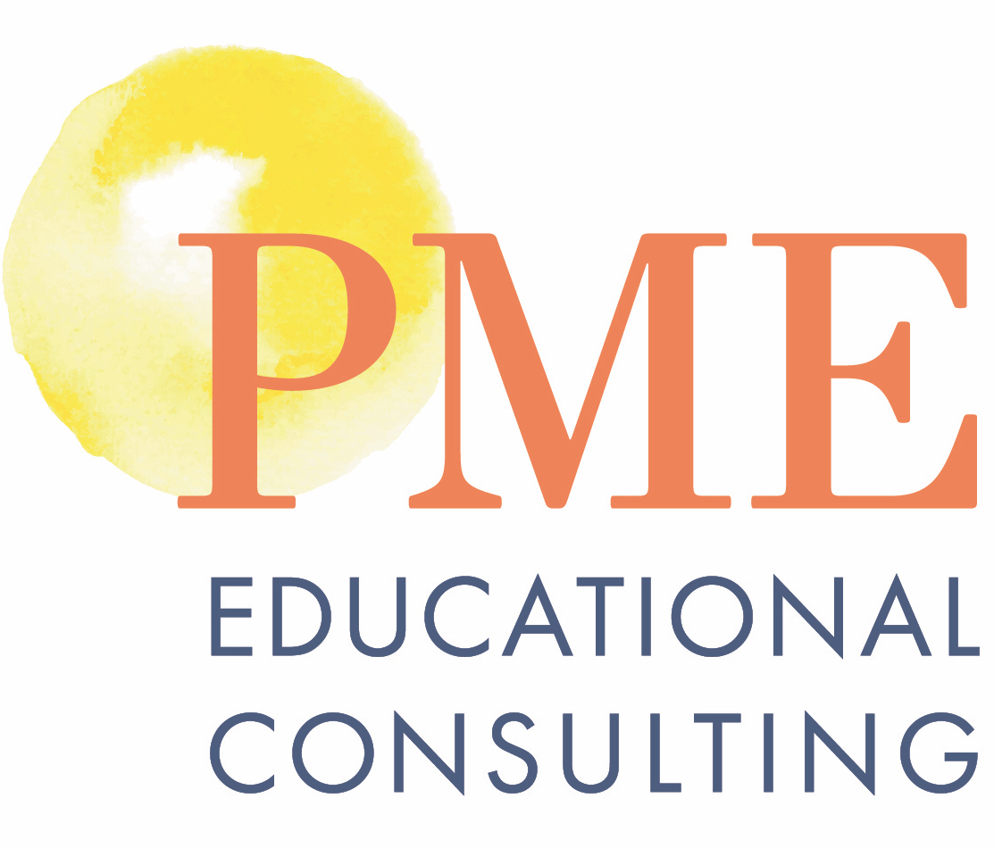

Executive Functioning Lesson Series

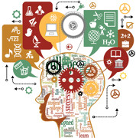

Did you know: “The single greatest predictor of academic success is executive functioning. It even trumps IQ.” – Dr. John Medina, Developmental Molecular Biologist and Author of the bestseller book, Brain Rules.

In this two-day workshop, participants will explore;
- What is Executive Functioning and how the brain serves as the CEO of your mind
- Strategies, tools, apps and resources students can use to grow their executive function skills to be more successful in life.
- Executive Assessment tools to identify strengths and areas to develop
- Activities that promote: Self-Awareness, Organization, Planning, Goal-Setting, Flexible Thinking, Problem-Solving, Attention Control, Self-Monitoring And Emotional Control, Task Initiation, Time Management And Working Memory
- Participate in lessons that focus on:
- Goal Setting and Creating Action Plans
- Planning and Prioritizing
- Flexible Thinking
- Organization
- Time Management
- Working Memory
- Extension Activities
*Features, such as Goal-Setting, Digital Portfolio, and supporting Playlists, and many more tools on the Thrively Platform will be used to enhance each lesson.

