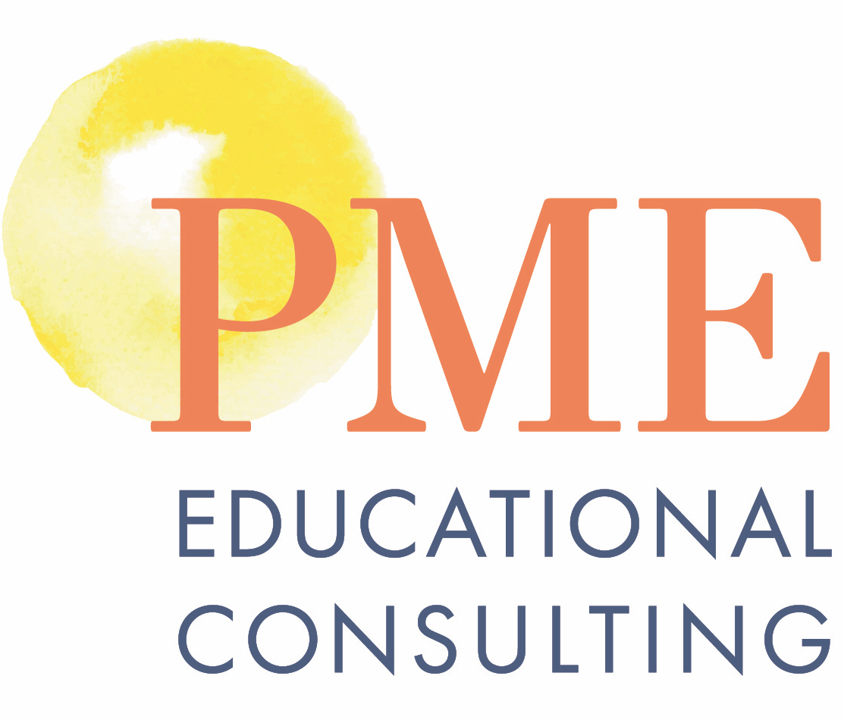

Helping Students Realize Their Strength, Interests and Aspirations
through the Thrively Strengths-based Platform
Learning Support programs embody an individualized, student-centered approach. As students steer through the complexities of the educational system, self-advocacy and efficacy become critical to their success. Life beyond the classroom requires an ever-evolving set of skills and competencies. In order to find success, students must build a fuller understanding of themselves and learn how to apply their strengths, interests, and aspirations in charting a path into the future. They must engage in meaningful work, connect to the world beyond the school walls, and know their own rich potential.
In support of this complex set of challenges, Thrively has developed one single, comprehensive program that can guide schools in their work to empower all students to be intrinsically motivated, productive, lifelong learners. From their industry-first Strength Assessment to their strengths-based IEP Project, and from real-world skill development to goal-driven Digital Portfolios, Thrively offers tools to enable the full array of Learning Support initiatives.
In this one-day workshop, participants will learn about:
- Putting the student at the center of the conversation and empower every student/family/teacher with detailed understanding of strengths, interests, learning styles, aspirations, etc. using the Strengths Assessment, and other Assessment tools to help students discover their strengths and interests, find passion and purpose, build social-emotional and life skills, and gain experience through authentic learning engagements.
- The Well-Being Index and Thrively’s partnership with Turnaround for Children to provide a daily student Well-Being Index based on research that points to 3 common elements across settings that contribute to positive emotional development: Supportive Environment, Developmental Relationships, and Opportunities for integrated academic skill, and mindset development. https://www.youtube.com/watch?v=Q79nM8SD9k0&authuser=0
- Thrively’s Signature Hope Index, a two—minute evidence-based tool that measures hope levels in students and staff with complimenting evidence-based lessons for students to learn hope-based practices that increase their daily well-being and form long-term habits.
- Thousands of hours of curated lessons and projects that are ready to use in the classroom, including CASEL’s aligned SEL Programs for K-12.
- Building consistent SEL delivery across the K-12 continuum by developing organized, grade-level specific Playlists of existing Thrively Lessons.
- Enhancing student-to-student and teacher-student interaction via the collaboration feed within the Project Tool.
- Promoting engaging PBL instruction across the faculty via the scaffolded approach built into the Project Tool (i.e., start with off-the-rack Thrively projects, build edited versions of Thrively projects, ultimately design their own projects).
- Capturing student growth beyond grades and scores using the goal-driven Digital Portfolio.
- Learning the power of reflection-driven lessons for Advisory,

