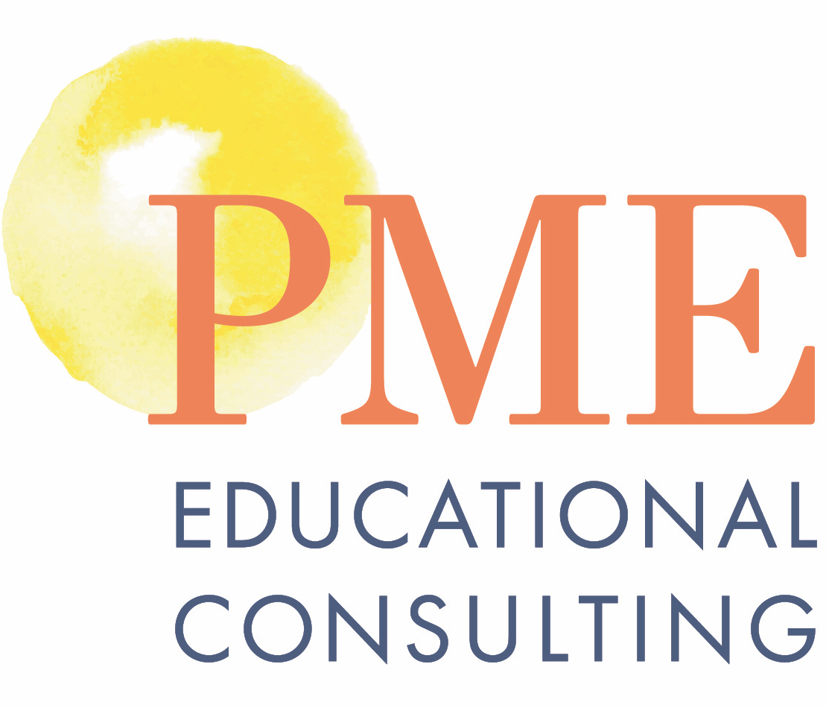

Narrow the Reading Gap

In collaboration with the Levy Learning Center, the following Professional Development Training series is available to educators who are committed to narrowing the reading gap which has been exacerbated by the pandemic. Research-based evidence confirms that some children are at risk for reading difficulties. We also know that reading impacts one’s ability to succeed in life and that learning to read opens doors to endless opportunities. Early intervention mitigates this dilemma.
Educators have been discussing the “right way” to teach reading for years. There used to be a dichotomy between phonics instruction (the explicit teaching of letters and sounds) and the whole language approach (a focus on discovery and making meaning). Science has ﬁnally shown that there is a clear progression to eﬀective literacy instruction. First, and foremost, is the need for children to understand the principles of spelling-sound correspondences and to solidify a set of high-frequency words to read words and phrases ﬂuently. Most children need explicit teaching to build this knowledge. After decoding and high-frequency sight words are established, then more attention can be devoted to comprehension with a focus on meaning. (MaxScholar)

The Orton-Gillingham (OG) approach is a highly structured way to teach phonics. It is explicit, systematic, and multi-sensory. It is often referred to as “structured literacy.” The MaxScholar OG approach is based on the traditional method of teaching Orton-Gillingham, but it oﬀers a version which is web-based. This enables a teacher to start with a direct approach, then allows students to work on their own with software which guides them to mastery. This drill and practice till mastery model is essential for improving phonemic awareness and phonics. Then it is easy to apply this to reading with comprehension.

Some facts about reading:
- If a child is not reading by 3rd grade, there is an 80% chance that he or she will not be reading by 8th grade.
- If a child is not reading by 8th grade, there is an 80% chance of him or her dropping out of school.
- If a child drops out of high school, there is a high likelihood of becoming incarcerated in the juvenile justice system.
- It costs over $130,000 per year to keep someone in a juvenile detention center. (William “Bill” Ellis, 1940-1995, President of Orton Society)

What is the Orton-Gillingham approach?
The Orton-Gillingham (OG) approach was ﬁrst conceived by Dr. Samuel T. Orton, a neuro- psychiatrist and pathologist who challenged Anna Gillingham, an educator, in the 1920s and 1930s to develop an approach for teaching reading to those children who suﬀered from “word blindness,” which is a term that has now been changed to “dyslexia.” When Anna Gillingham was teaching at the Friends School in Baltimore, she befriended another teacher, Diana Hanbury King, and taught her this Orton-Gillingham approach. It was Diana Hanbury King who taught the approach to our founder, Dr. Deborah Levy. It is Dr. Levy who has developed a training program and certiﬁcation process to teach more teachers and administrators an approach which has widespread use even beyond those children who have been labeled as having dyslexia.

Course Description
The on-line comprehensive training provides participants with an understanding of the MaxScholar Orton-Gillingham approach over the course of 30 hours.

Phase 1: Orton Gillingham Training
Orton-Gillingham is an approach intended primarily for use with individuals who have difficulty with reading, spelling, and writing, associated with dyslexia. It is a powerful tool of exceptional breadth, depth, and flexibility. This training is geared for teachers, especially Special Ed teachers, Literacy Coaches, Tutors, Speech & Language Therapists, ELL teachers, and Parents.

Participants will learn how to teach:
- phonological awareness,
- explicit, systematic, and multi-sensory phonics,
- ﬂuency,
- spelling,
- vocabulary,
- reading comprehension,
- written language.

This multi-sensory approach can be utilized in an existing English Language Arts (ELA) program or can be used as a stand-alone reading program.

This course is appropriate for:
- general education teachers of K-12 students,
- special education teacher of K-12 students,
- Title 1 teachers of K-12 students,
- literacy coaches,
- English Language Learner teachers,
- school administrators,
- tutors, and
- speech/language teachers.

It is also appropriate for anyone (including parents) who wants to expand their knowledge of the alphabetic code and foundation of the English language.

Participants will learn:
- How to administer informal assessments
- Phonological awareness assessment
- Multi-sensory strategies for reading, writing, spelling, vocabulary, reading comprehension, and written language
- Syllabication types and how to teach syllable pattern types
- How to develop an OG lesson plan
- How to use the MaxScholar OG software for student drill and practice till automaticity
OG Course Completion
Attendees will join a one-day 6hr training and receive a course completion certificate. Attendees will have the option of joining monthly follow up sessions that will
cover additional training topics and receive additional support.

The following will be covered in the course
including how to write OG lesson plans:
- Phonological Processing  - Morphonology (prefixes, suffixes, roots  - Phonics  - Vocabulary | - Decoding (syllable types)  - Grammar  - Encoding (spelling rules)  - Reading comprehension strategies

OG Level 1 & Dyslexia Certification Course
Besides the OG certification process, attendees will also attend Dyslexia webinars, and complete assignments.
This will result in OG & Dyslexia certification.

$2500 course
$265 instructional materials, including software, manipulatives, workbooks, and teacher manuals
OG Level 1 Certification Course
Attendees will join a one-day 6 hr. course, followed by
(7) 1 hour monthly follow up sessions, where they are
required to complete monthly assignments, that their
trainer will review and provide feedback. Please note
that the assignments and follow sessions are required to complete your practicum and receive
certification.

Available Dates*

- Tuesday, September 6, 2022

- Thursday, September 22, 2022

- Monday, October 3rd, 2022

- Saturday, October 8, 2022

- Thursday, October 13, 2022

- Thursday, November 10, 2022

Time
9:00 a.m. to 3:00 p.m. Eastern Time (Other times can be arranged to accommodate schools in different time zones.)

Program Includes
Full day online program
• Instructional Materials, including student workbooks and
teacher training manuals, other manipulatives
• Software licenses for attendee and for one student

The training with certification requires a mandatory 60-hour practicum, which includes providing lesson plans, providing videos of attendee working with students on the individual components of the lesson plans. Attendees will also have to provide documentation of 40 hours of students’ working on the software to show independent of the OG components. All these steps will be closely monitored by one of our master trainers and feed-back provided. The course consists of an initial 8-hour virtual training, and monthly follow-up. We have found that spreading the course over several months with an opportunity for attendees to ask questions and share experiences is far more effective than a single 30-hour course over 3 days with no formal follow-up. Our previous attendees have expressed to us that there is too much to learn in consecutive days, and often easy to get confused with what to do. By spreading the training out over several months, our attendees can achieve the maximum learning and still have time o get their questions answered.

Contact us for additional training dates and costs for each level courses.

